電通二乙微處理器實驗 實驗結報

實驗名稱 | Lab03-類比輸入
組別 |  | 組員 | 吳泯鴻

1. 實驗目的
使用 USB-Serial做為輸入輸出
讀取類比輸入之數值
量測0/0.5/1/1.5/2/2.5V之電壓值
量測可變電阻之數值
量測光敏電阻之數值
2. 實驗步驟
1.由Arduino傳送訊息給PC
PC經由Serial Monitor接收
由PC傳送指令1及0至Arduino
2.量測電壓值
3. 量測可變電阻值
4. 量測光敏電阻數值
3. 程式碼
byte val;
const byte LED =7;
void setup() {
Serial.begin(9600);
Serial.println("Hello World.");

}

void loop() {
if(Serial.available()){
val= Serial.read();
if(val=='1')
{
digitalWrite(LED,HIGH);
Serial.println("LED ON");
}
else if(val=='0')
{
digitalWrite(LED,LOW);
Serial.println("LED OFF");
}
}
}

float Analogin =0;
void setup() {
Serial.begin(9600);
}

void loop() {
for(int i=0;i<=5;i++)
{
Analogin =0.7* Analogin+0.3*analogRead(14);
}
Serial.println(Analogin);
float Vin = Analogin*2.5/4095;
Serial.println(Vin);
delay(500);
}
float sensorValue= 0;
float sensorVoltage;
float R1;
int ResisterValue =1000000;
void setup() {
Serial.begin(9600);

}

void loop() {
for(int i=0;i<=5;i++)
{

sensorValue =0.7* sensorValue+0.3*analogRead(A1);
}
sensorVoltage = sensorValue*5/4095;
R1=sensorVoltage*(ResisterValue)/5;
Serial.print(sensorValue);
Serial.print(" ");
Serial.print(sensorVoltage);
Serial.print(" ");
Serial.println(R1);
delay(500);
}
float sensorValue= 0;
float sensorVoltage;
float R1;
int ResisterValue =3300;
void setup() {
Serial.begin(9600);

}

void loop() {
for(int i=0;i<=5;i++)
{

sensorValue =0.7* sensorValue+0.3*analogRead(A1);
}
sensorVoltage = sensorValue*2.5/4095;
R1=sensorVoltage*(ResisterValue)/5;
Serial.print(sensorValue);
Serial.print(" ");
Serial.print(sensorVoltage);
Serial.print(" ");
Serial.println(R1);
delay(500);
}
4. 實驗結果及分析
0 | 5.8 | 0  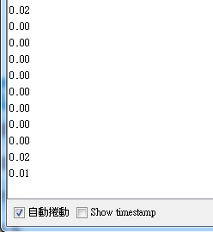
0.5 | 820 | 0.5  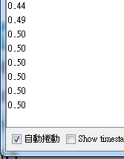
1 | 1651 | 1.0  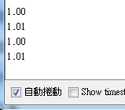
1.5 | 2482 | 1.51  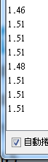
2 | 3304 | 2.02  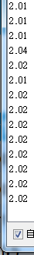
2.5 | 4095 | 2.5  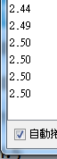

5. 心得討論
今次實驗學習到如何依靠程式碼電阻數值及電壓值
6.
